June 20, 2014

Alisa Woideck  
4917 E Saint Brides Circle  
Orlando, FL   
San Diego, CA 92107

Dear Alisa Woideck:

This year’s Health Data Consortium’s HealthDatapalooza was a resounding success, and the Code-A-Palooza challenge was no exception. Out of 60 team applications and 10 finalists, 3 teams were chosen as the 2014 winners taking home $35,000 in cash prizes. The three winners, Lyfechannel, Accordion Health, and Karmadata each applied the CMS Provider Utilization data set in unique, sophisticated, and novel ways with beautifully designed dashboards and patient centric data visualizations.

While unfortunately TeamFloriduh did not place, we did gain the opportunity to work with a number of other developer groups attending HealthDatapalooza and we look forward to these future partnerships. Our current platform integration plans range from social health insights to ACO mapping, population health management, and more. Additionally, we are allocating resources for FOIA requests to gain access to more open government health data sets. As a community effort, questions, comments, suggestions, and critiques are more than welcomed. Our growing platform is first and foremost for patients, consumers, caretakers, and data junkies like you.

None of this would have been remotely possible without your help and support, and for that we are incredibly grateful. Enclosed is a receipt for your generous donation, and the necessary information so that you may deduct your donation come tax time. Floridata Foundation is a 501(c)(3) non-profit, and will remain that way indefinitely. Our EIN is N14000004497, and any questions concerning non-profit status may be directed to Lauren Still.

Sincerely,

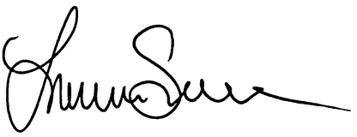

Lauren Still  
Founder, Floridata Foundation